Rajasthan Hindi High School
Annual Result
Academic year 2024-25

Std. | Total no. of appeared students | Passed & promoted | Detained  Students | Percentage
9A | 64 | 63 | 1 | 98.44
9B | 63 | 60 | 3 | 95.24
9C | 64 | 61 | 3 | 95.31
9D | 48 | 46 | 2 | 95.83
11A | 63 | 62 | 1 | 98.41
11B | 63 | 61 | 2 | 96.83
11C | 64 | 62 | 2 | 98.41
11D | 65 | 59 | 6 | 90.77
11E | 51 | 47 | 4 | 92.16

Std. | Girls | Boys | Total | Passed  Girls | Passed Boys | Total | Detained  Girls | Detained  Boys
9A | 30 | 34 | 64 | 30 | 33 | 63 | 0 | 1
9B | 33 | 33 | 64 | 30 | 30 | 60 | 3 | 0
9C | 26 | 38 | 64 | 26 | 35 | 61 | 0 | 3
9D | 20 | 28 | 48 | 19 | 27 | 46 | 1 | 1

Rankers

First Rank. 9A.
Shukla Mahika Vishnukumar 94.43 %
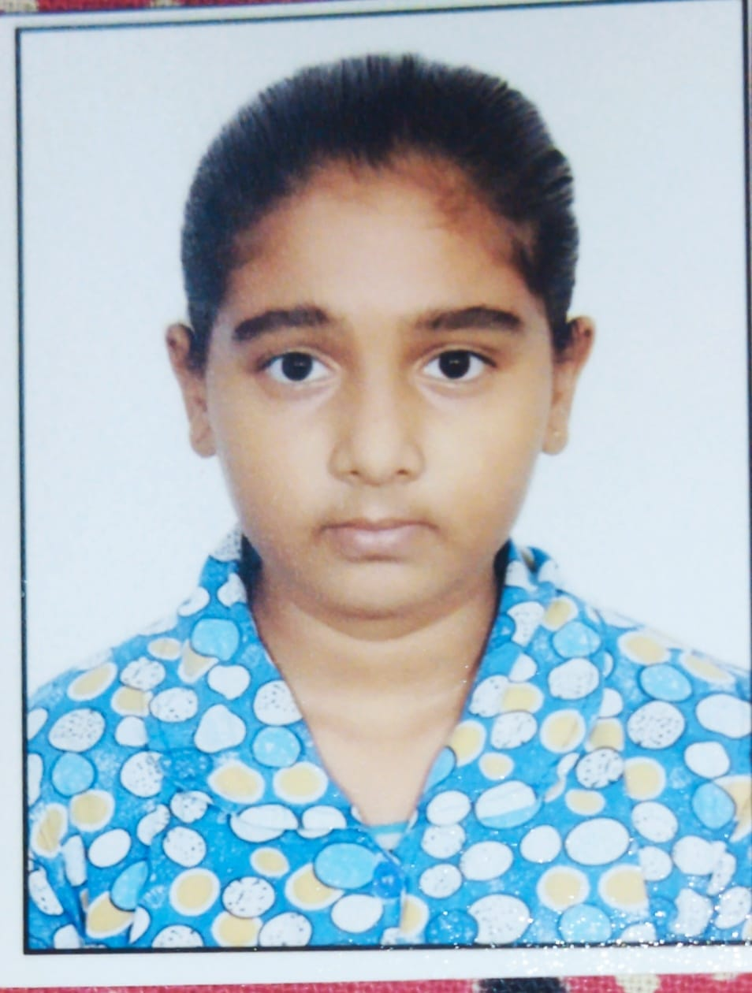

Second Rank
Nagori Ruchika Arvind. 90%


Third Rank
Jain Ronit Kumar Kamlesh. 88.57%
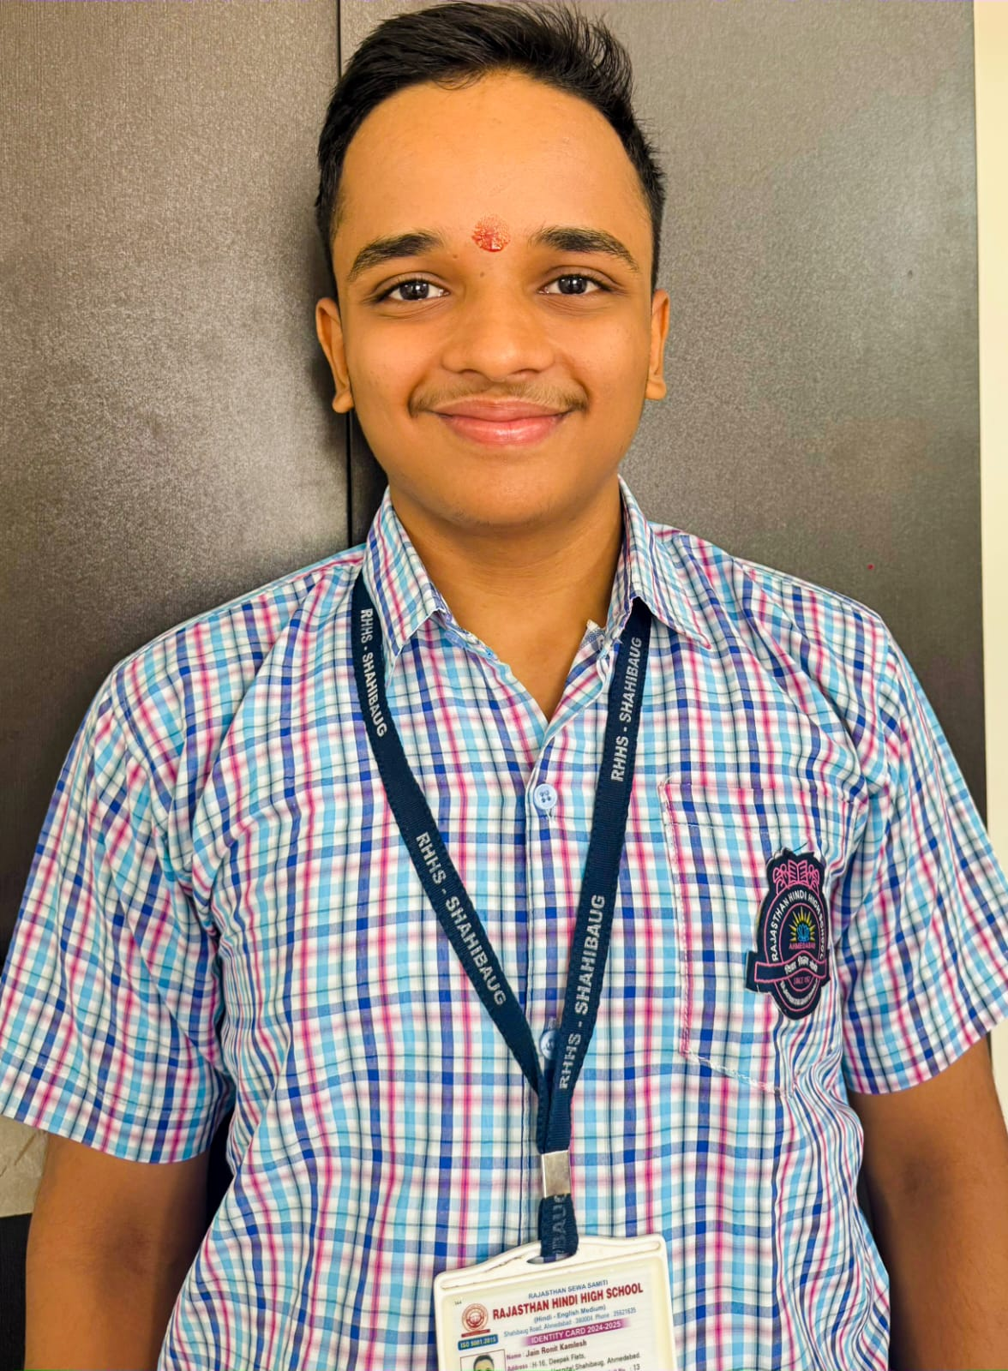

Fourth rank
Vedant jayprakash. 86.71%
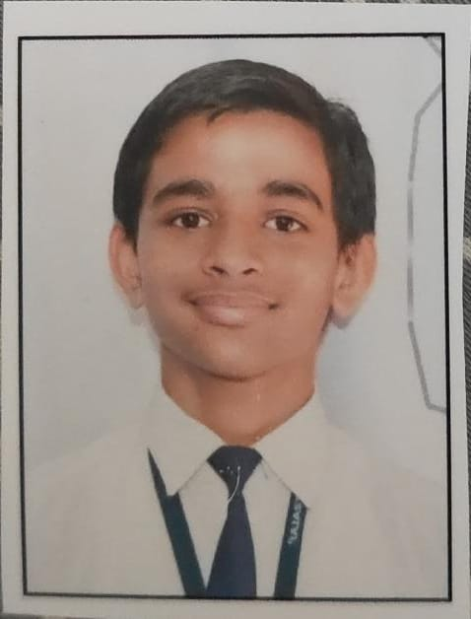

9B
First rank
Khanna Parnal Veerendra
88.71%
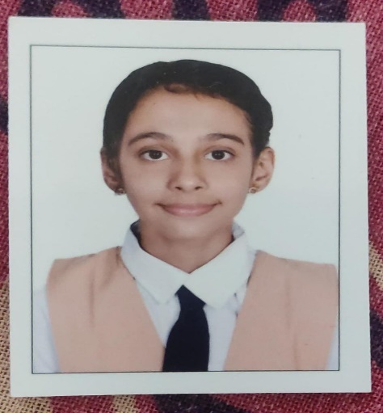

Second rank
Shah Aishwarya 84 .71%

Third rank
Mali Jinal. 84%


Fourth rank
Panchal Helly. 82.14%
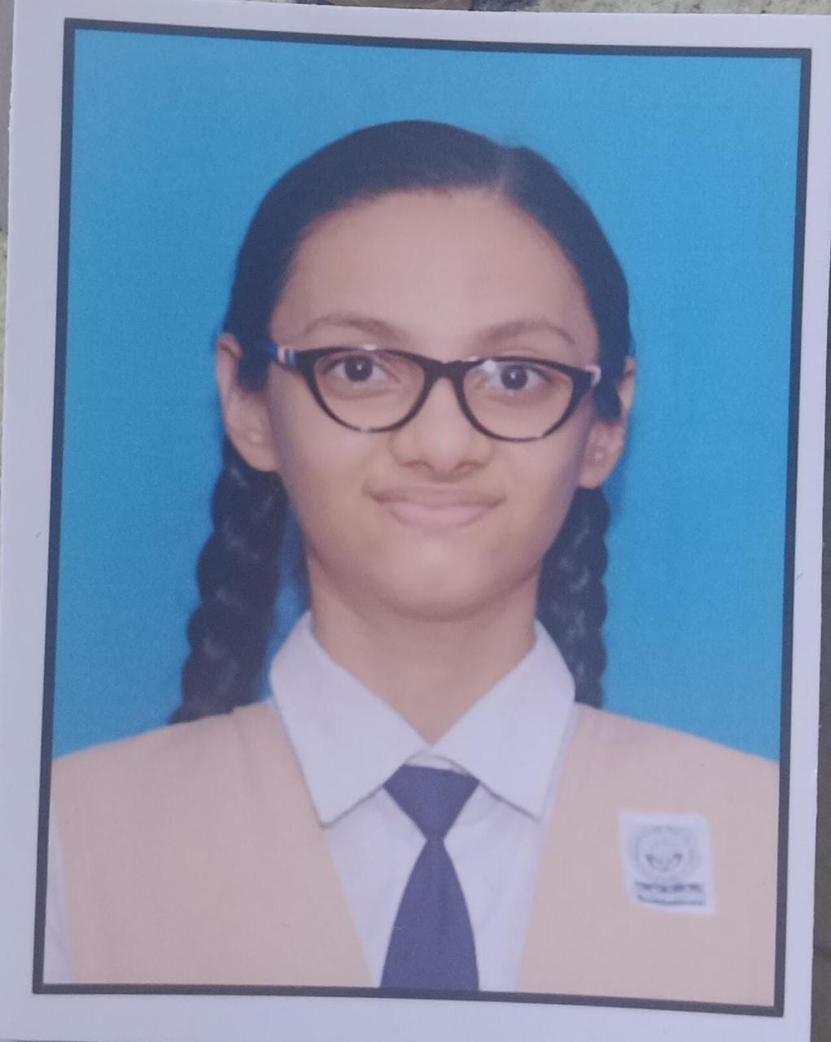
9C
First rank
Sharma Urvi Amit Kumar 90.71%
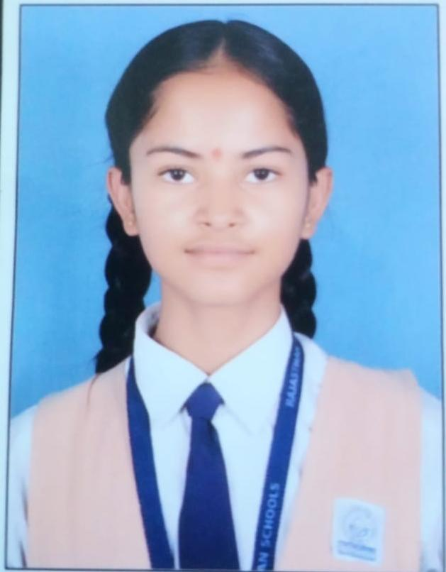

Second Rank
Tomar Riddhi Karansingh. 90.17%
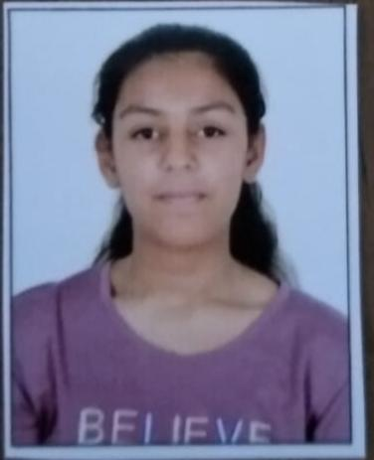

Third Rank
Rao Seema Jitendrasingh. 90.14%

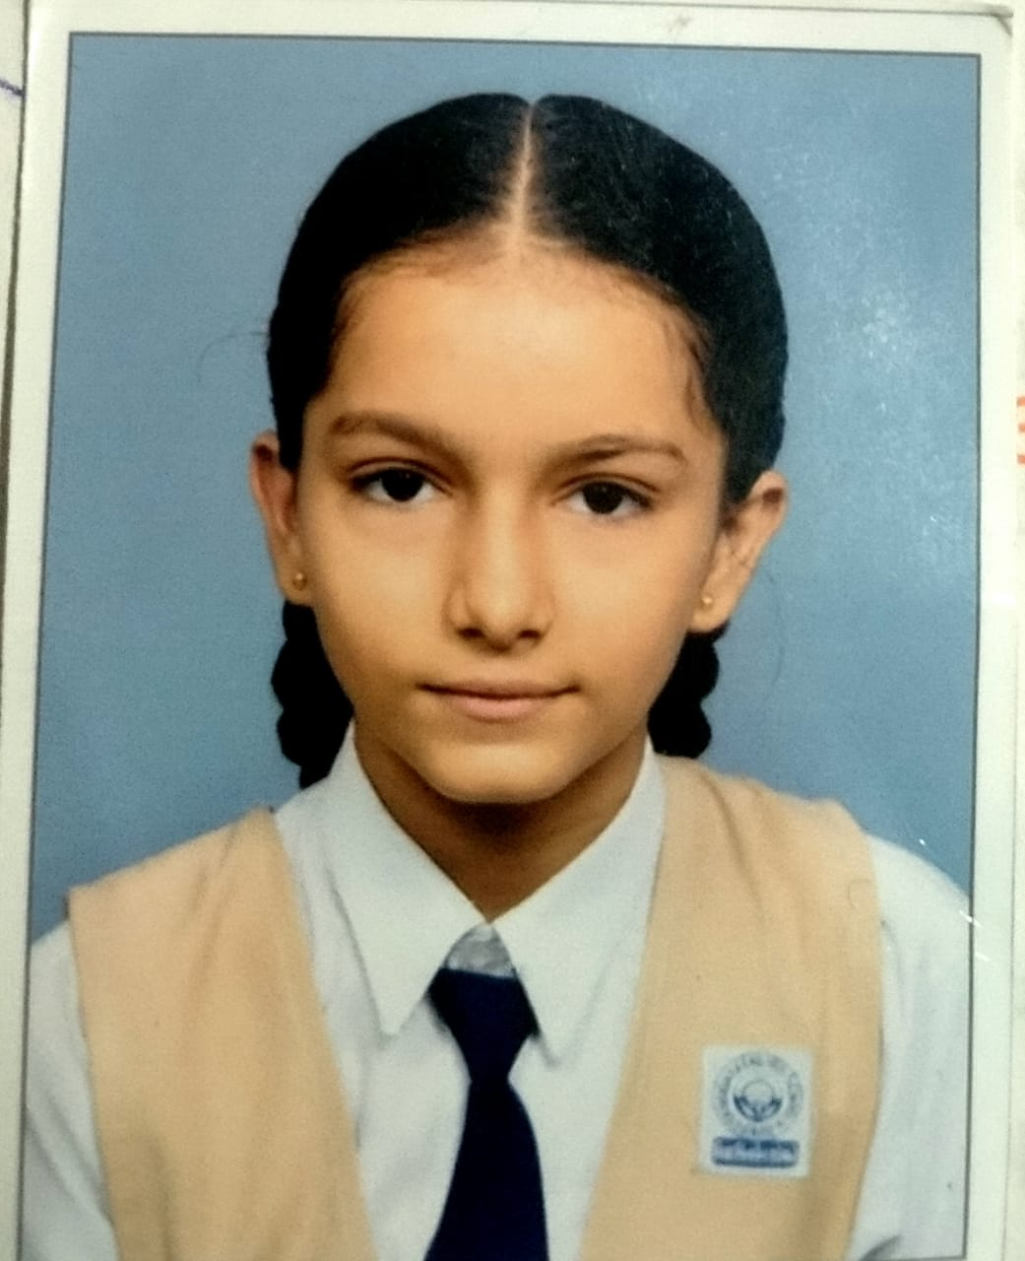

Fourth rank

Rajput Prince Mahendra Singh 88.14%

9D

First rank
Yadav Aaryan A. 82%



Second rank
Prajapati Mangilal M. 72.56%

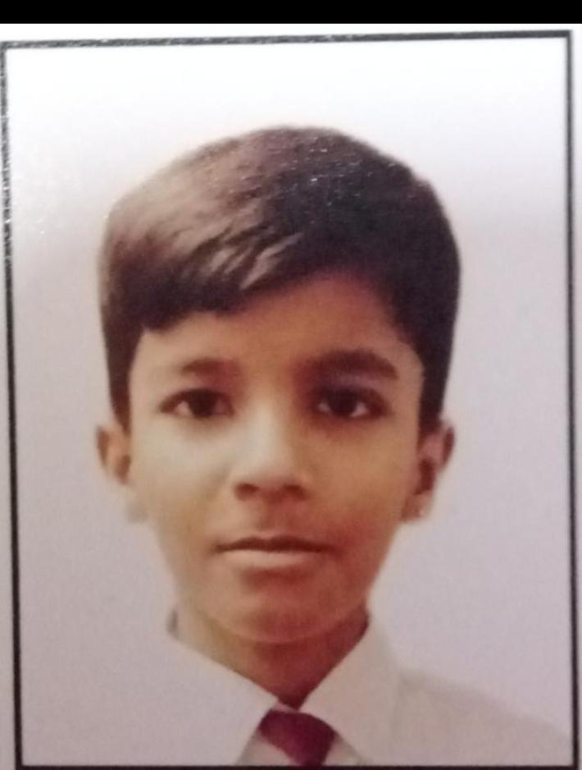

Third Rank
Telly Bhagwati H. 72.42


10A
1 Panchal Krish 98.62



2 Jain Pari 97.88%

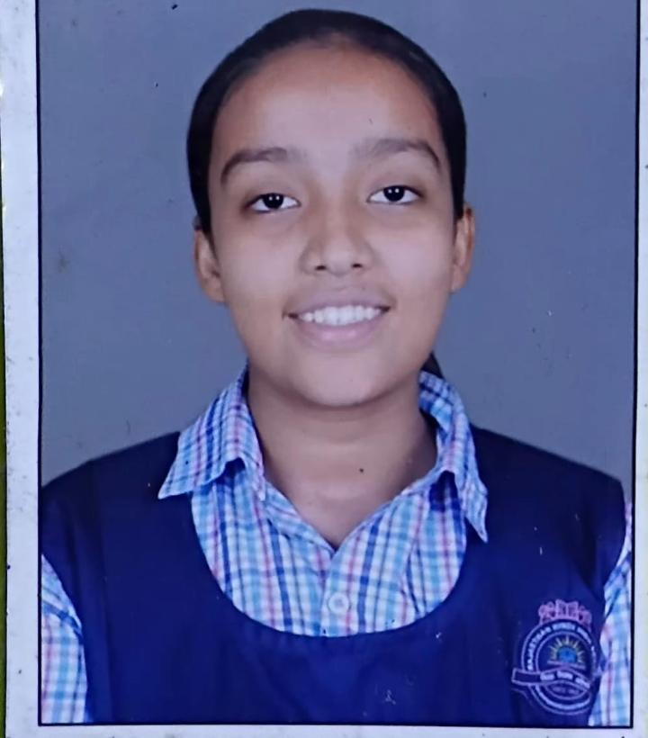

3 Rai Mahimasingh 97.88

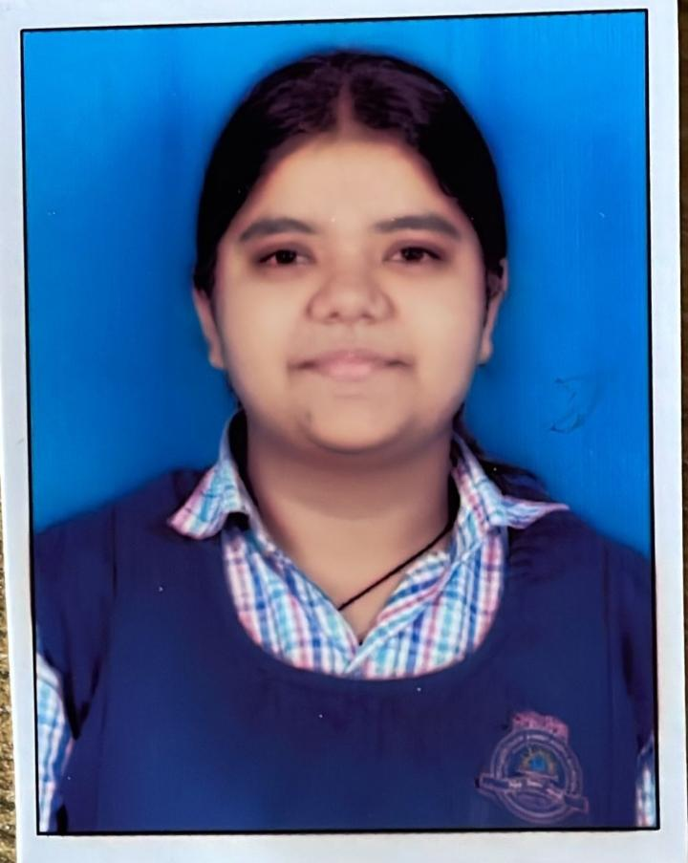

10D
1 Kori Sanjana 95.79
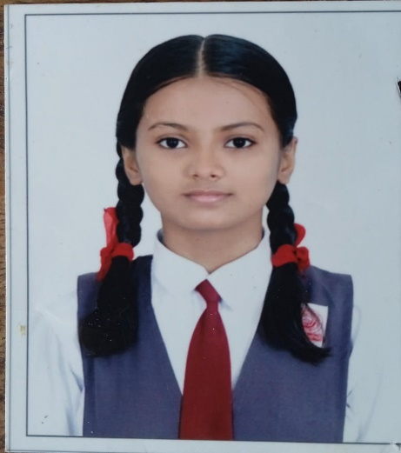

2 Jayswal Anisha B 91.06
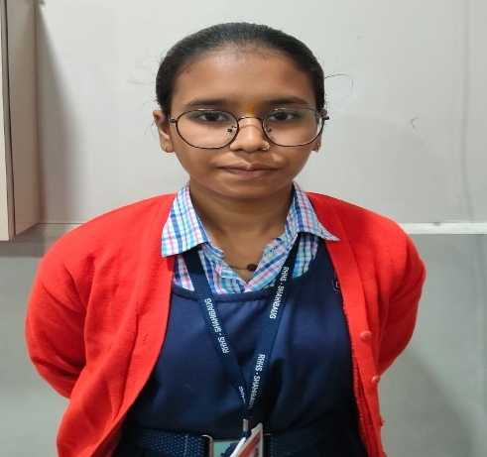

3 Gupta Rudra 90 48

